[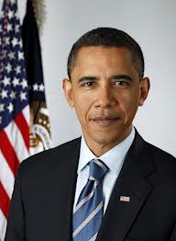](http://www.google.com/imgres?q=obama&hl=en&safe=active&biw=1366&bih=587&tbm=isch&tbnid=FBaZ9FAF1G0IiM:&imgrefurl=http://www.whitehouse.gov/administration/president-obama&docid=ZstgDwzCFGMfZM&imgurl=http://www.whitehouse.gov/sites/default/files/administration-official/ao_image/President_Official_Portrait_HiRes.jpg&w=1200&h=1634&ei=HqlgUIvmEIGsywGzsoDYCg&zoom=1&iact=hc&vpx=89&vpy=109&dur=1482&hovh=262&hovw=192&tx=111&ty=142&sig=103269841639302295660&page=1&tbnh=125&tbnw=93&start=0&ndsp=26&ved=1t:429,r:0,s:0,i:70)

[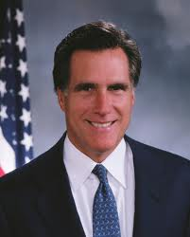](http://www.google.com/imgres?q=mitt+romney&hl=en&safe=active&biw=1366&bih=587&tbm=isch&tbnid=qpjCBPilKYS4vM:&imgrefurl=http://reason.com/quiz/GOP2011/profile/mitt-romney&docid=jEYjhtyUzPi-rM&imgurl=http://reason.com/assets/mc/mriggs/MittRomneyProfilePic.jpg&w=824&h=1024&ei=Q6lgUPeILaiMyQHnkoGADA&zoom=1&iact=hc&vpx=183&vpy=116&dur=515&hovh=250&hovw=201&tx=101&ty=131&sig=103269841639302295660&page=1&tbnh=127&tbnw=100&start=0&ndsp=25&ved=1t:429,r:1,s:0,i:73)